EXPT NO:7 | IMPLEMENT ADVANCED CHART TYPES USING TABLEAU AND  POWER BI
DATE: 14.08.2026

PRE-LAB QUESTIONS (PROVIDE BRIEF ANSWERS TO THE FOLLOWING QUESTIONS)

- What is data integration in the context of Business Intelligence (BI)?
Data integration is the process of combining data from different sources into a single, unified view. In Business Intelligence (BI), it helps organizations analyze all their data together instead of looking at separate datasets. This provides a complete picture of business performance and supports better decision-making. It also saves time by reducing the need to manually combine data from different systems.

- Explain the difference between a join and a data blend in Tableau.
A join combines two or more tables into one table using a common field, such as Region or Customer ID. It is performed at the data source level before creating visualizations and works best when the data comes from the same source.
A data blend, on the other hand, combines data from different data sources while creating the visualization. It links the data using a common field but keeps the original data sources separate. Data blending is useful when joining the data directly is not possible.

- What are relationships and cardinality (e.g., one-to-many, many-to-many) in Power BI's data model?
Relationships connect different tables using a common column so that Power BI can analyze related data together. They help users create reports by combining information from multiple tables without duplicating data.
Cardinality defines how the records in one table relate to records in another table. For example, a one-to-many relationship means one record in one table is linked to many records in another table, while a many-to-many relationship means multiple records in both tables can be connected. Choosing the correct relationship improves the accuracy of reports and calculations.

- Why is data quality (e.g., consistent naming conventions, data types) crucial when integrating data from different sources?
Data quality is important because it ensures that the information used for analysis is accurate, complete, and reliable. If names, data formats, or data types are inconsistent, the tables may not match correctly during integration.
Poor-quality data can lead to incorrect calculations, misleading charts, and wrong business decisions. Maintaining clean and consistent data also makes dashboards easier to understand and more trustworthy for users.

- Name two common challenges encountered during data integration.
Two common challenges during data integration are inconsistent data formats or naming conventions and missing or duplicate data. These issues can make it difficult to combine datasets correctly and may affect the accuracy of reports.
Another challenge is integrating data from different systems that use different structures or formats. Resolving these issues often requires data cleaning and transformation before analysis can begin.

IN-LAB EXERCISE:
OBJECTIVE:
To connect, combine, and model data from multiple sources in Tableau and Power BI and create a unified, comprehensive dashboard for holistic analysis.

PROCEDURE:
- Data Collection:
  - Import two datasets:
    - Dataset 1: Sales Data (CSV) → Order ID, Order Date, Region, Sales Amount
    - Dataset 2: Regional Sales Targets (Excel) → Region, Sales Target, Target Year
- Data Preparation and Transformation:
  - Clean datasets (e.g., standardize "N. America" → "North America"). • Ensure correct data types (numeric for Sales, date for Order Date).
  - Handle missing values appropriately.
- Data Integration and Modeling:
  - Tableau: Create a join/relationship on the Region field in the Data Source pane.
  - Power BI: Use the Model view to create a relationship on Region; define cardinality (e.g., many-to-one).
- Create Calculated Fields for Comparison:
  - Target Achievement % = (SUM(Sales) / SUM(Sales Target)) * 100
  - Sales vs. Target Variance = SUM(Sales) - SUM(Sales Target)
- Design a Comprehensive Dashboard:
  - Combine visuals from both sources.
  - Add KPI cards: Total Sales, Overall Target Achievement %.
  - Use gauge/bullet charts for region-wise target performance.
  - Combined bar chart: Actual Sales vs. Target by Region.
  - Map visualization: Sales vs. Target Variance by region.
- Validate Data Integrity:
  - Cross-check joined data for accuracy.
  - Ensure dashboard filters correctly update visuals.
- Publishing and Sharing:
  - Tableau: Publish to Tableau Public or Server.
  - Power BI: Publish to Power BI Service and share.
Experiment Datasets:
  - Dataset 1: Retail Sales Data (CSV) → Order ID, Order Date, Region, Sales
  - Dataset 2: Regional Sales Targets (Excel) → Region, Sales Target, Target Year

Power BI
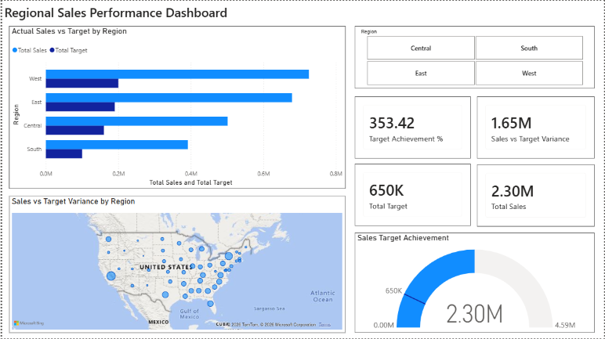

Tableau
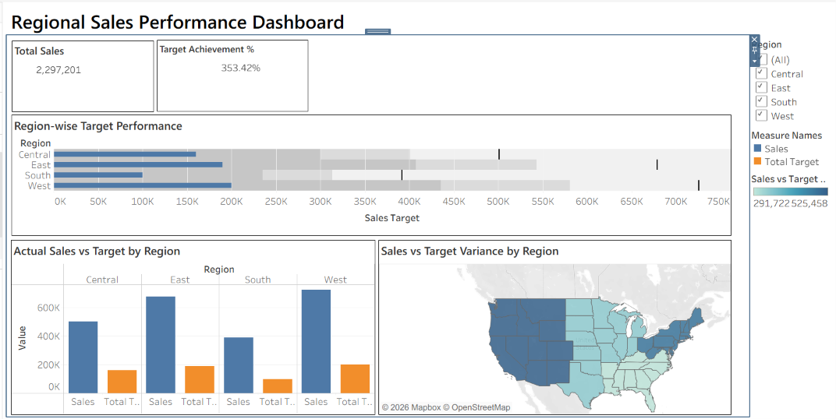

POST-LAB QUESTIONS (PROVIDE BRIEF ANSWERS TO THE FOLLOWING QUESTIONS)
- How did integrating the sales targets data provide a more complete analytical picture than using the sales data alone?
Integrating the sales targets with the actual sales data made it possible to compare performance against planned goals. Instead of only knowing how much was sold, we could also see whether each region met, exceeded, or fell short of its target. This gave a clearer understanding of business performance and helped identify areas that needed improvement. It also made it easier to monitor progress and evaluate overall business performance more effectively.

- Describe the type of join or relationship you used to combine the two datasets and explain why it was the appropriate choice.
In Power BI, I created a many-to-one relationship between the Sales table and the Regional Sales Targets table using the Region column. The Sales table contained multiple records for each region, while the Targets table had one target value for each region. This relationship was appropriate because it allowed the sales records to be matched with their corresponding regional targets, making it easy to create comparisons and calculations. As a result, all dashboard visuals displayed accurate and meaningful insights.

- What challenges, if any, did you face regarding data granularity or mismatched keys (e.g., different region names) between the two sources?
One challenge was ensuring that the region names were consistent in both datasets. If the region names were different or spelled differently, the relationship would not work correctly. To solve this, the data was cleaned by standardizing the region names and checking for missing or incorrect values before creating the relationship. This ensured that the integrated data was accurate and reliable for analysis.

- How can creating variance calculations (e.g., Sales vs. Target) help a business manager make better decisions?
Variance calculations help managers quickly identify whether actual sales are above or below the planned targets. This makes it easier to recognize high-performing regions as well as areas that need attention. Based on these insights, managers can adjust sales strategies, allocate resources more effectively, and set realistic future targets. They also help in tracking performance trends and improving business planning over time.

- What other data source (e.g., marketing campaign data, customer demographics) could you integrate to further enrich this analysis, and what new insights might it provide?
Another useful data source would be customer demographics, such as age group, gender, or location. Integrating this data with sales information would help identify which customer groups contribute the most to sales and which regions have higher demand. These insights could support better marketing strategies, improve customer targeting, and increase overall sales performance.

RESULT:

The retail sales and regional targets datasets were successfully connected, cleaned, and integrated in Tableau and Power BI. Relationships between the sources created a unified data model. The dashboard visualized sales performance against targets, enabling variance analysis and providing insights into regional performance not possible with a single data source.

ASSESSMENT

Description |  | Max Marks | Marks Awarded
Pre Lab Exercise |  | 5
In Lab Exercise |  | 10
Post Lab Exercise |  | 5
Viva |  | 10
 | Total | 30
 | Faculty Signature

